Personal Portfolio Website Development

Software Requirements Specification

Group members-

1.Argade Vaishnavi Prashant (2107)

2.Baheti Ritika Manoj (2112)

3.Bhalerao Sayali Sandip (2118)

Portfolio Website development

**Table of Contents**

**1.INTRODUCTION**

* PURPOSE
* SCOPE
* DEFINITIONS
* REFERENCES
* OVERVIEW

**2. GENERAL DESCRIPTION**

**3. SPECIFIC REQUIREMENTS**

* + FUNCTIONAL REQUIREMENTS
    - <Functional Requirement or Feature #1>
    - <Functional Requirement or Feature #2>
  + USE CASES
    - Use Case #1
    - Use Case #2
  + NON-FUNCTIONALREQUIREMENTs
    - Performance
    - Reliability
    - Availability
    - Security
    - Maintainability
    - Portability
  + DATABASE REQUIREMENTs
  + OTHER REQUIREMENTS

**4. ANALYSIS MODELS**

* DATA FLOW DIAGRAMS (DFD)
* Use case Diagrams
* SEQUENCE DIAGRAMS
* Class diagram
* Activity diagram
* State chart diagram

**1.INTRODUCTION:**

A personal portfolio website is a website that showcases an individual's skills, accomplishments, and projects. It is a valuable tool for professionals in various fields, including artists, designers, developers, writers, and other creatives, to showcase their work and attract potential clients or employer’s. A personal portfolio website typically includes an "about" section that introduces the individual and their background, a portfolio section that showcases their work, a contact page that provides a way for visitors to get in touch, and often a blog section where the individual can share their thoughts, ideas, and experiences.

Developing a personal portfolio website requires a combination of technical and creative skills. It involves designing and coding a website that is visually appealing, easy to navigate, and showcases the individual's work effectively. It also requires the ability to write compelling copy, choose appropriate images, and present information in a clear and concise manner. Creating a personal portfolio website can be a valuable investment in one's career. It can help individuals establish their brand, showcase their skills and achievements, and attract new clients or job opportunities.

* PURPOSE:

The purpose of personal portfolio website development is to showcase an individual's skills, achievements, and projects in a professional manner. The website serves as a virtual resume and portfolio, allowing visitors to easily access information about the individual's work and experience. the primary audience for a personal portfolio website is potential clients or employers who are interested in the individual's work. This may include recruiters, hiring managers, creative directors, professor’s or other professionals in the individual's industry. The website can also be a valuable resource for networking and building relationships with other professionals in the field.

In addition to potential clients and employers, a personal portfolio website can also be a useful tool for the individual themselves. It can help them establish their personal brand, reflect on their accomplishments, and set goals for their future career development.

* SCOPE:

The scope for personal portfolio website development can vary depending on the individual's goals and requirements. Here are some common elements that may be included in the scope of a personal portfolio website:

1. Design: The website design should be visually appealing, professional, and showcase the individual's personal brand. This may involve creating a unique colour scheme, typography, and layout.
2. Content: The website content should effectively communicate the individual's skills, achievements, and projects. This may include an "about" section, a portfolio section, a blog section, and a contact page.
3. Development: The website should be developed using appropriate technologies and coding standards. It should be optimized for speed and usability across multiple devices and browsers.
4. Search Engine Optimization (SEO): The website should be optimized for search engines to ensure it ranks well in search engine results pages (SERPs).
5. Maintenance: The website should be regularly maintained and updated to ensure it remains current and relevant. This may involve updating the design, content, and functionality.
6. Analytics: The website should be set up with analytics tools to track website traffic, user behaviour , and other important metrics.

The scope of a personal portfolio website may also depend on the individual's industry and target audience. For example, an artist may include high-quality images of their work, while a software developer may include code snippets or links to their Git hub profile.

Top of Form

Bottom of Form

* DEFINATIONS:

A personal portfolio website is a website that showcases an individual's skills, accomplishments, and projects in a professional manner. It is a collection of an individual's work and experience that serves as a virtual resume and portfolio. The website typically includes an "about" section that introduces the individual, a portfolio section that showcases their work, a contact page that provides a way for visitors to get in touch, and often a blog section where the individual can share their thoughts, ideas, and experiences. The purpose of a personal portfolio website is to establish the individual's personal brand, showcase their skills and achievements, and attract potential clients or job opportunities. It is commonly used by professionals in various fields, including artists, designers, developers, writers, and other creatives.

* REFERENCES:

Here are some references that can help with personal portfolio website development:

1. "How to Build a Personal Website: An Easy Step-by-Step Guide" by Anna Gat, published on Skill crush. This article provides a comprehensive guide on how to build a personal website from scratch, including choosing a platform, designing the website, and adding content.
2. "10 Examples of Well-Crafted Personal Portfolio Websites" by WDD staff, published on Web Designer Depot. This article showcases 10 examples of personal portfolio websites that are well-designed and effectively showcase the individual's work.
3. "Portfolio Tips & Tricks: Building a Strong Personal Portfolio Website" by Richard Lazazzera, published on Shopify. This article provides tips and tricks for creating a strong personal portfolio website, including choosing a domain name, designing the website, and optimizing it for search engines.
4. "10 Tips for Designing a Stunning Portfolio Website" by Creative Blog Staff, published on Creative Blog. This article provides tips for designing a stunning portfolio website, including choosing a layout, selecting typography and colours, and optimizing images.
5. "Building a Personal Website: Essential Tips and Resources" by Cameron Chapman, published on Tuts+. This article provides essential tips and resources for building a personal website, including choosing a platform, designing the website, and promoting it to potential clients or employers.

Top of Form

Bottom of Form

* OVERVIEW:

A Software Requirements Specification (SRS) for a personal portfolio website development project typically provides an overview of the project's goals, requirements, and features. It outlines the purpose of the website, its intended audience, and the functionality that the website should provide. The SRS may also describe the project's scope, timeline, and budget.

**2. GENERAL DESCRIPTION:**

Personal portfolio website development involves creating a website that showcases an individual's skills, experience, and achievements in a professional manner. The website serves as a virtual resume and portfolio, providing potential clients or employers with a way to learn more about the individual's work and skills. the development process typically involves choosing a platform, designing the website, and adding content. The website may include an "about" section that introduces the individual, a portfolio section that showcases their work, a blog section where the individual can share their thoughts and ideas, and a contact page that provides a way for visitors to get in touch.

The design of the website should be visually appealing and professional, and the content should effectively communicate the individual's skills and experience. The website should also be optimized for speed and usability across multiple devices and browsers, and be search engine optimized (SEO) to ensure it ranks well in search engine results pages (SERPs). Overall, personal portfolio website development is an important tool for professionals in various fields, including artists, designers, developers, writers, and other creatives, to establish their personal brand and attract potential clients or job opportunities.

Top of Form

**3. SPECIFIC REQUIREMENTS:**

* FUNCTIONAL REQUIREMENTS:

Here are some examples of functional requirements for personal portfolio website development:

1. Home Page: The website should have a homepage that provides an overview of the individual's skills, experience, and achievements.
2. About Section: The website should include an "about" section that introduces the individual, their background, and their professional interests.
3. Portfolio Section: The website should have a portfolio section that showcases the individual's work, including images, videos, and descriptions.
4. Blog Section: The website should include a blog section where the individual can share their thoughts, ideas, and experiences related to their profession.
5. Contact Page: The website should have a contact page that provides a way for visitors to get in touch with the individual, such as a contact form, email address, or phone number.
6. Social Media Integration: The website should integrate with the individual's social media profiles, such as Twitter, LinkedIn, or Instagram.
7. Responsive Design: The website should be designed to be responsive and display properly on all devices, including desktops, tablets, and smartphones.
8. Search Engine Optimization: The website should be optimized for search engines, including the use of meta descriptions, relevant keywords, and proper header tags.
9. Analytics: The website should include analytics tools, such as Google Analytics, to track website traffic and user behaviour.
10. Content Management System (CMS): The website should be built using a CMS, such as WordPress or Drupal, to allow the individual to easily update and manage the content on the website.

* USE CASES:U

Here are some use cases for personal portfolio website development:

1. Job Seekers: An individual looking for a job in a creative field, such as graphic design or web development, can create a personal portfolio website to showcase their skills and experience to potential employers.
2. Freelancers: Freelancers, such as writers, photographers, or videographers, can create a personal portfolio website to showcase their work and attract potential clients.
3. Artists: Artists, such as painters or sculptors, can create a personal portfolio website to showcase their artwork and connect with potential buyers or galleries.
4. Educators: Educators, such as professors or trainers, can create a personal portfolio website to showcase their teaching experience, publications, and research.
5. Consultants: Consultants, such as marketing or management consultants, can create a personal portfolio website to showcase their expertise and attract potential clients.
6. Entrepreneurs: Entrepreneurs, such as startup founders or business owners, can create a personal portfolio website to showcase their vision and accomplishments, and attract potential investors or partners.
7. Non-Profit Organizations: Non-profit organizations can create a personal portfolio website to showcase their mission, impact, and accomplishments, and attract potential donors or volunteers.

Overall, personal portfolio websites can be used by a variety of professionals and organizations to establish their brand, showcase their work or accomplishments, and attract potential clients, employers, or partners.

Top of Form

Bottom of Form

* + NON-FUNCTIONAL REQUIREMENTs:
* Performance:

Performance is an important aspect of personal portfolio website development, as it affects the user experience and the website's search engine ranking. Here are some key performance considerations for personal portfolio website development:

1. Speed: The website should load quickly, as users tend to abandon websites that take too long to load. This can be achieved through optimizing images, reducing server response time, and minimizing code and script sizes.
2. Usability: The website should be easy to navigate and use, with clear and concise content and a responsive design that adapts to different devices and screen sizes.
3. Mobile Optimization: The website should be optimized for mobile devices, as a significant portion of website traffic comes from mobile devices. This can be achieved through responsive design, mobile-friendly fonts, and touch-friendly navigation.
4. Security: The website should be secure, with proper encryption, secure hosting, and regular security updates to protect against hacking and malware.
5. SEO Optimization: The website should be optimized for search engines, with proper meta descriptions, relevant keywords, and proper header tags to improve its search engine ranking.
6. Analytics: The website should have analytics tools, such as Google Analytics, to track website traffic and user behavior, and identify areas for improvement.
7. Content Optimization: The website's content should be optimized for readability and engagement, with clear headings, concise paragraphs, and relevant visuals.

Overall, personal portfolio websites should be designed with performance in mind, to provide a seamless user experience and attract potential clients or employers.

Top of Form

Bottom of Form

* Reliability:

Reliability is an important aspect of personal portfolio website development, as it ensures that the website is available and accessible to users whenever they need it. Here are some key considerations for ensuring the reliability of a personal portfolio website:

1. Hosting: The website should be hosted on a reliable and secure web hosting service, with a guaranteed uptime and 24/7 technical support.
2. Backup and Recovery: The website should have regular backups of its data and files, and a recovery plan in case of a system failure or data loss.
3. Maintenance and Updates: The website should have regular maintenance and updates, including security patches, bug fixes, and software updates to ensure that it remains stable and reliable.
4. Testing: The website should undergo regular testing, including load testing, to ensure that it can handle heavy traffic and perform consistently under different conditions.
5. Content Management: The website's content should be managed using a reliable and secure content management system (CMS), with proper permissions and backups to prevent data loss or unauthorized access.
6. Security: The website should have proper security measures in place, including SSL encryption, firewalls, and intrusion detection systems, to prevent hacking and unauthorized access.
7. User Support: The website should have a reliable and responsive user support system, with clear contact information and a ticketing system to handle user inquiries and issues.

Overall, ensuring the reliability of a personal portfolio website requires a combination of technical measures, regular maintenance, and a user-centric approach to support and content management.

* Availability:

Availability is an important aspect of personal portfolio website development, as it ensures that the website is accessible to users whenever they need it. Here are some key considerations for ensuring the availability of a personal portfolio website:

1. Hosting: The website should be hosted on a reliable and secure web hosting service, with a guaranteed uptime and 24/7 technical support.
2. Content Delivery Network (CDN): A CDN can be used to distribute website content across multiple servers in different geographic locations, which can improve website speed and availability.
3. Scalability: The website should be designed to handle increases in traffic, and should have proper load balancing and caching mechanisms to ensure that it remains available under heavy loads.
4. Disaster Recovery: The website should have a disaster recovery plan in place, including regular backups of data and files, and a plan for recovering from a system failure or data loss.
5. Monitoring: The website should be monitored using tools such as uptime monitoring and performance monitoring, to detect and address issues before they affect website availability.
6. Redundancy: The website should have redundant systems in place, including backup servers and redundant internet connections, to ensure that it remains available even in the event of a system failure.
7. User Support: The website should have a reliable and responsive user support system, with clear contact information and a ticketing system to handle user inquiries and issues.

Overall, ensuring the availability of a personal portfolio website requires a combination of technical measures, regular maintenance, and a user-centric approach to support and content management.

Top of Form

* Security:

Security is an important aspect of personal portfolio website development, as it ensures that the website and its users are protected from unauthorized access, data breaches, and other security threats. Here are some key considerations for ensuring the security of a personal portfolio website:

1. SSL Encryption: The website should use SSL encryption to secure data transmitted between the user's browser and the server.
2. Secure Hosting: The website should be hosted on a secure and reliable web hosting service that uses firewalls, intrusion detection systems, and other security measures to protect against attacks.
3. Strong Passwords: The website should use strong passwords for user accounts, and should enforce password complexity rules and regular password changes.
4. User Permissions: The website should use role-based access control to restrict user access to sensitive data and functions.
5. Regular Updates: The website's software and plugins should be kept up-to-date with the latest security patches and updates.
6. Data Backup: The website should have regular backups of its data and files, and a plan for recovering from a data loss or system failure.
7. Malware Protection: The website should use anti-virus and anti-malware software to detect and remove malware and other security threats.
8. User Education: Users should be educated on best practices for online security, such as creating strong passwords and avoiding suspicious links and attachments.

Overall, ensuring the security of a personal portfolio website requires a combination of technical measures, regular maintenance, and user education to protect against security threats and keep user data safe.

* Maintainability:

Maintainability is an important aspect of personal portfolio website development, as it ensures that the website can be easily updated, modified, and fixed over time. Here are some key considerations for ensuring the maintainability of a personal portfolio website:

1. Clean Code: The website should be built with clean, well-organized code that is easy to read and understand.
2. Modularity: The website's code should be modular and well-organized, making it easy to add new features or make changes without affecting the rest of the codebase.
3. Version Control: The website's code should be stored in a version control system, such as Git, to make it easy to track changes and revert to previous versions if necessary.
4. Documentation: The website should be well-documented, with clear and concise documentation for the code, APIs, and any third-party libraries or services used.
5. Testing: The website should be thoroughly tested, with automated tests and manual testing to ensure that it functions correctly and reliably.
6. Maintenance Plan: The website should have a maintenance plan in place, with regular updates, backups, and security checks to ensure that it remains functional and secure over time.
7. Accessibility: The website should be designed with accessibility in mind, making it easy for users with disabilities to access and use the website.

Overall, ensuring the maintainability of a personal portfolio website requires a combination of technical measures, regular maintenance, and a user-centric approach to design and development. By building a maintainable website, developers can ensure that the website remains functional, reliable, and secure over time, and that it can be easily updated and modified as needed

* Portability:

Portability is an important aspect of personal portfolio website development, as it ensures that the website can be easily moved or migrated to different environments or platforms. Here are some key considerations for ensuring the portability of a personal portfolio website:

1. Platform Independence: The website should be built using platform-independent technologies and standards, such as HTML, CSS, and JavaScript, to ensure that it can be accessed on different devices and platforms.
2. Cross-Browser Compatibility: The website should be designed to work across different web browsers and operating systems, ensuring that it is accessible to the widest possible audience.
3. Content Separation: The website's content should be separated from its presentation, using technologies like CSS and templates, making it easier to move the website to different platforms or redesign it.
4. Data Formats: The website's data should be stored in standard formats, such as JSON or XML, making it easy to transfer the data between different platforms or applications.
5. Deployment Flexibility: The website should be designed to be easily deployed to different hosting environments, such as shared hosting, virtual private servers, or cloud platforms.
6. Portability Testing: The website should be thoroughly tested for portability, ensuring that it can be easily moved or migrated without losing functionality or data.

Overall, ensuring the portability of a personal portfolio website requires a combination of technical measures, design choices, and testing, to ensure that the website can be easily accessed and moved across different platforms and environments. By building a portable website, developers can ensure that the website remains accessible and usable, even as technology and platforms evolve over time.

* + DATABASE REQUIREMENTs:

A personal portfolio website may or may not require a database, depending on the specific features and functionality of the website. Here are some examples of how a database might be used in a personal portfolio website:

1. Content Management: If the website has a blog or other content management features, it may require a database to store and organize the content.
2. User Accounts: If the website has user accounts, a database may be used to store user information, such as usernames, passwords, and profile information.
3. Contact Forms: If the website has a contact form, the data submitted through the form may be stored in a database for future reference.
4. Analytics: If the website uses analytics tools to track user behavior and traffic, the data may be stored in a database for analysis.

If a database is required for a personal portfolio website, some common database options include MySQL, PostgreSQL, and MongoDB. The choice of database will depend on the specific needs and requirements of the website. Additionally, it's important to ensure that the database is properly secured and backed up to prevent data loss or unauthorized access.

Top of Form

* + OTHER REQUIREMENTS:

1.A High-Quality Image of Yourself

2. Information about yourself

3.Your best projects

4. Services

5.Contact information

6. Free samples

7. Identify your best work samples

8. Create a contents section

9.Include your resume

10.Add a personal statement outlining your professional goals

11.List out your hard skills and expertise

12.Attach samples of your best work

13.Include recommendation and testimonial from credible sources.

**4.ANALYSIS MODELS:**

Use Case Diagrams:

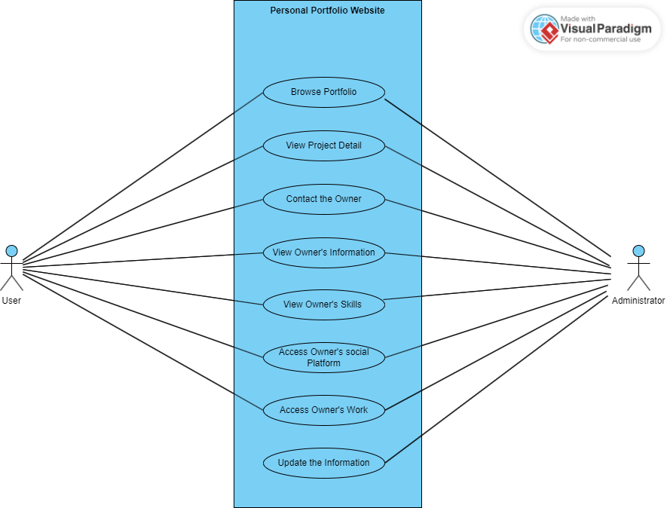

Use Case diagram 1

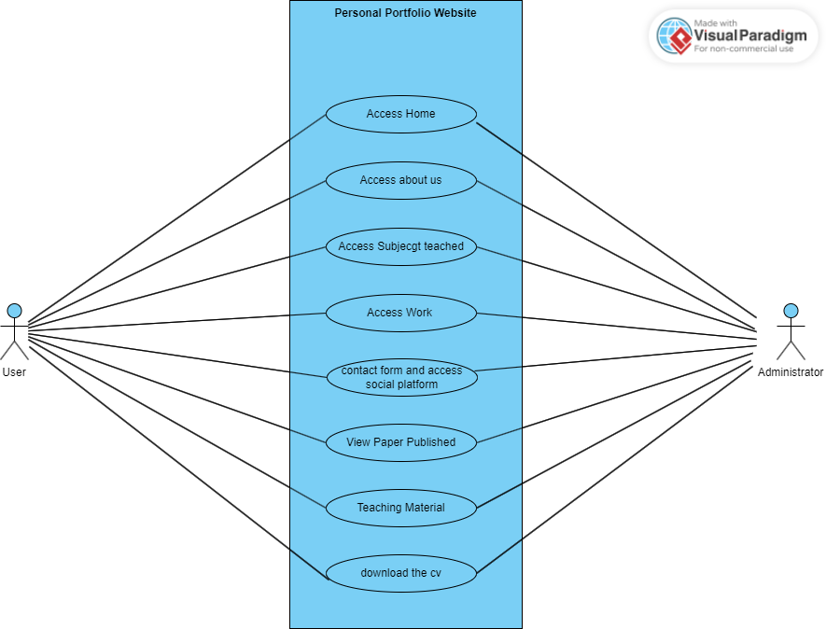

Use case diagram 2